C PROGRAMMING
NAME : VISHAAL G
REG NO : 1921260043
COURSE CODE : CSA0222
Task 6: Read and Print Data Correctly (4 marks)
6.1 Format specifiers
Data type | Format specifier
int | %d
unsigned int | %u
long | %ld
long long | %lld
float in printf | %f
double in printf | %f
double in scanf | %lf
char | %c
String | %s

6.2 Input validation program
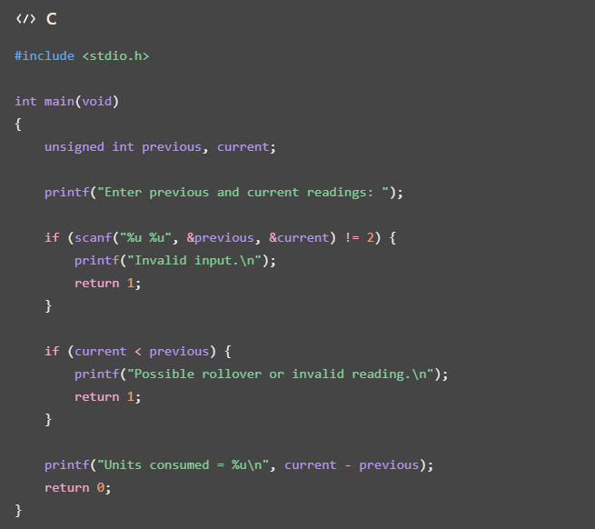
This simple example rejects decreasing readings rather than automatically treating them as rollovers. A production program should check whether a rollover is valid and distinguish it from an incorrect reading.
Why format specifiers matter: Using %d to print a long is incorrect and causes undefined behaviour. Always use the correct format specifier for the actual type.

6.3 Printing a bill
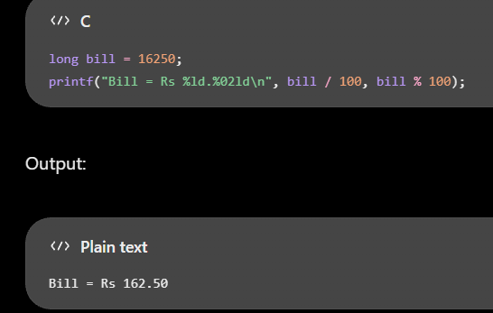
6.4 Alternative: fgets() and strtol()
fgets() reads an entire line into a character buffer. strtol() converts the text into an integer and can detect invalid characters and range errors.
For a line containing \(L\) characters, reading and parsing take \(O(L)\) time and require \(O(L)\) buffer space. This approach is usually easier to recover from invalid input because the entire line can be discarded before reading the next one.

